

SYMBIOSIS INTERNATIONAL (DEEMED UNIVERSITY)
(Established under section 3 of the UGC Act 1956)
Re-accredited by NAAC with “A” Grade

Name of the Student: Sneha Sah PRN: 25070122189
Semester: 3 Year: AY 25-29

ASSIGNMENT No: 3
TITLE: Develop a Java application demonstrating method overloading and the use of static variables, methods in class design.

Problem Statement : Develop a Java application demonstrating method overloading and the use of static variables, methods in class design.

Theory :

Java supports method overloading, which allows multiple methods with the same name but different parameters. It helps perform similar tasks in different ways using one method name.
A static variable is shared by all objects of a class, while a static method belongs to the class and can be called without creating an object.

In this application, overloaded bill() methods calculate bills for dine-in, takeaway, and delivery orders. A static variable counts the total orders, and a static method displays the total number of orders. This demonstrates the use of method overloading and static members in Java.

Exercise 1.

Develop a Calculator program using overloaded methods for addition of integers and decimals. Use a static variable to count calculations.
Source code:

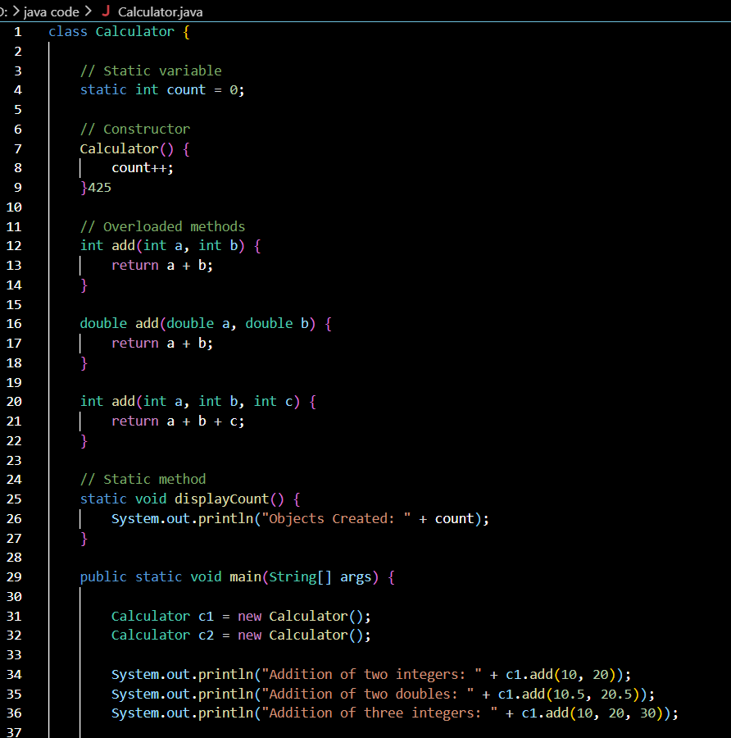


Output:
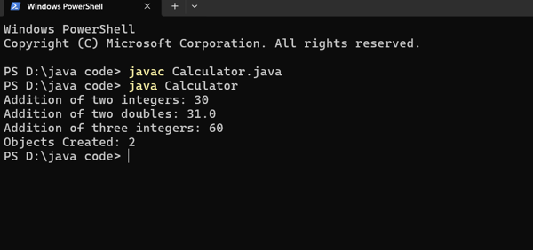

2. Develop a Restaurant Billing Application where overloaded methods calculate bills for dine-in, takeaway, and delivery orders, while static variables track total orders.

Source code:
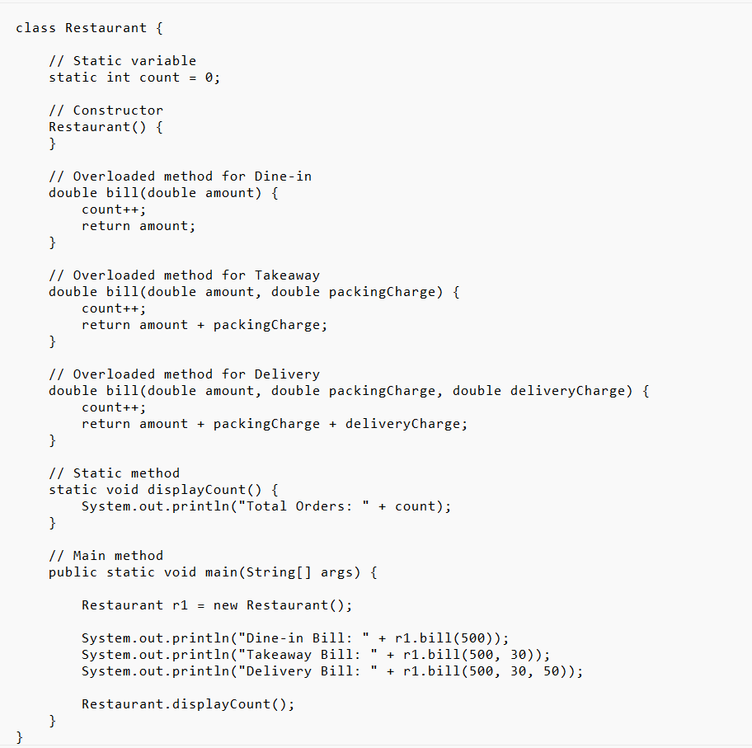

OUTPUT:
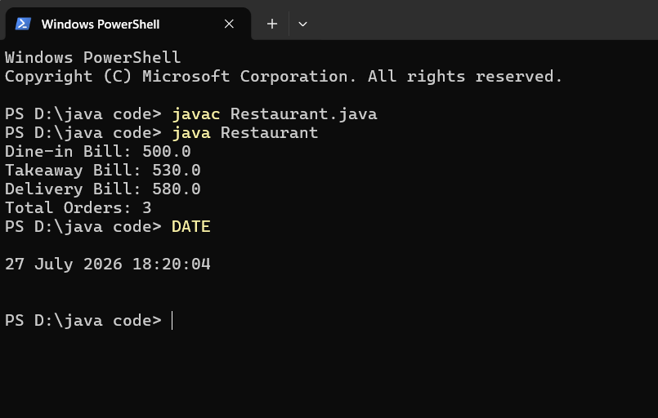

Conclusion :
In this experiment, I learned how method overloading and static variables and methods work in Java. By creating different bill() methods, I was able to calculate the bill for dine-in, takeaway, and delivery orders using the same method name but different parameters. This made the program simple, organized, and easy to understand.
I also learned that a static variable is shared by all objects of a class and can be used to store common information, such as the total number of orders. The static method helped display this information without creating another object. This experiment improved my understanding of Java object-oriented programming concepts and showed how these features are useful in developing real-world applications like restaurant billing systems.

